

School of Science, Computing and Engineering Technologies

Object Oriented Programming
Pass Task 11.1: Clock in Another Language

Overview
When learning a new language it is always best to create a small program that you are familiar with. In this task you will recreate the Clock class from the previous task in a new programming language.

Purpose:

Task:

Time:
See that the principles you have learnt apply equally to other object oriented programming languages.
Implement your Clock class and supporting Counter class in a different object oriented programming language.
End of Week 12, Friday 25 Oct 2024, 23:59:00 (Firmed)

Submission Details
All students have access to the Adobe Acrobat tools. Please print your solution to PDF and combine it with the screenshots taken for this task.
- Program source code
- Screenshot of program execution
- Screenshots comparing the memory usage and execution time between your clock application implemented in C# and your newly selected programming language.

Instructions
Review your design for the clock from the previous pass task, and use this to implement the Clock in a different OO programming language. You can use any OO programming language except for C#, and you must recreate the design from the previous task.
Hints. See next page for references regarding how to measure memory usage and execution time with C#, Java, and Python.

Note: We do not require unit test implementation for this task. You could work out how to do unit test-ing in the other language at a later stage at your own study.



Object Oriented Programming Pass Task 11.1 — Clock in Another Language

Assessment Criteria
Make sure that your task has the following in your submission:
- The program is implemented correctly based on the original clock design.
- Code must mostly follow the coding conventions of your chosen language.
- The “Universal Task Requirements” (see Canvas) have been met.
Hints.
With C#, you can add the following code at the end of your Program.cs to measure the physical memory usage of your current process.
//Get the current process System.Diagnostics.Process proc = System.Diagnostics.Process.GetCurrentProcess();
Console.WriteLine("Current process: {0}", proc.ToString());
//Display the total physical memory size allocated for the current process Console.WriteLine("Physical memory usage: {0} bytes", proc.WorkingSet64);
// Display peak memory statistics for the process. Console.WriteLine("Peak physical memory usage {0} bytes", proc.PeakWorkingSet64);
- Reference for the memory usage with C#: https://learn.microsoft.com/en-us/dotnet/ api/system.diagnostics.process.totalprocessortime?view=net-8.0

To measure the elapsed execution time, you can use the Stopwatch class in .Net framework. Please refer to the following link for an example. https://learn.microsoft.com/en-us/dotnet/api/system.diagnostics.stopwatch?view=net-6.0
With Java, you can use the Runtime class to measure the memory usage. The following code will help you measure the used memory in bytes.

// Get the total memory available to the JVM in bytes long totalMemory = runtime.totalMemory();
// Get the free memory available to the JVM in bytes long freeMemory = runtime.freeMemory();
// Calculate the used memory in bytes
long usedMemory = totalMemory - freeMemory;
- Reference for the memory usage with Java: https://www.geeksforgeeks.org/java-runtime- totalmemory-method/

- Reference for the Stopwatch class to measure the elapsed time in Java. https://introcs.cs.princeton.edu/java/stdlib/Stopwatch.java.html

With Python, you can use either Tracemalloc or Psutil library to monitor the memory usage. Reference is provided below.

https://www.geeksforgeeks.org/monitoring-memory-usage-of-a-running-python-program/

import tracemalloc
import time
class Counter:
def __init__(self, name):
self._name = name
self._count = 0

def increment(self):
self._count += 1

def reset(self):
self._count = 0

@property
def name(self):
return self._name

@name.setter
def name(self, value):
self._name = value

@property
def ticks(self):
return self._count

class Clock:
def __init__(self, counter):
self.seconds = Counter("seconds")
self.minutes = Counter("minutes")
self.hours = Counter("hours")

def update(self):
self.seconds.increment()
if self.seconds.ticks == 60:
self.seconds.reset()
self.minutes.increment()
if self.minutes.ticks == 60:
self.minutes.reset()
self.hours.increment()
if self.hours.ticks == 24:
self.hours.reset()
self.minutes.reset()
self.seconds.reset()

def display(self):
return f"{self.hours.ticks:02}:{self.minutes.ticks:02}:{self.seconds.ticks:02}"

def main():

seconds = "seconds"
counter = Counter(seconds)
clock = Clock(counter)

for i in range(24):
print(clock.display())
clock.update()

if __name__ == "__main__":
tracemalloc.start()
start = time.time()
main()
end = time.time()
print(end - start)
print(tracemalloc.get_traced_memory())

# stopping the library
tracemalloc.stop()
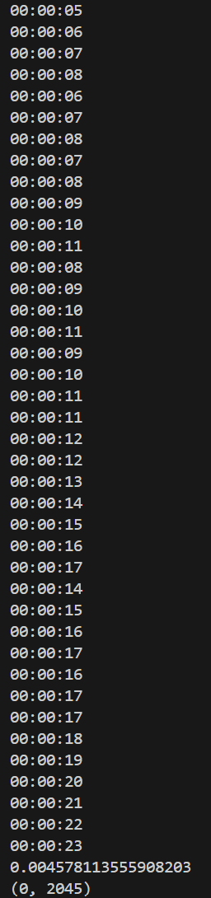

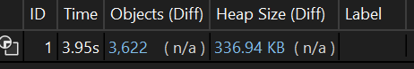

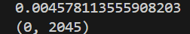

Page 2 of 2

